John Bell CS296N Lab 3 Part 1 Screenshots
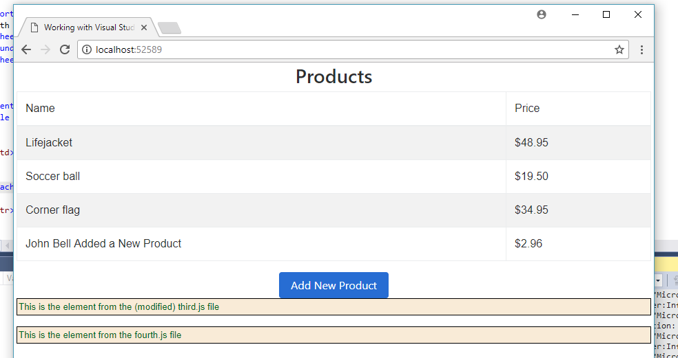
UNIT TESTS –
It was not discovering my product tests, so the screenshot includes the class as well so you can see it was completed at least
